STAT 615/415 Regression
SAS University Edition: Shared Folder for Data Files and SAS Codes
In the University Edition of SAS, you can keep data files in a designated shared folder. This folder is local on your computer, and it is accessible by SAS.
- See if you have a shared folder.
Start Oracle VM VirtualBox Manager. Go to Settings, and in the Settings window, choose Shared Folders
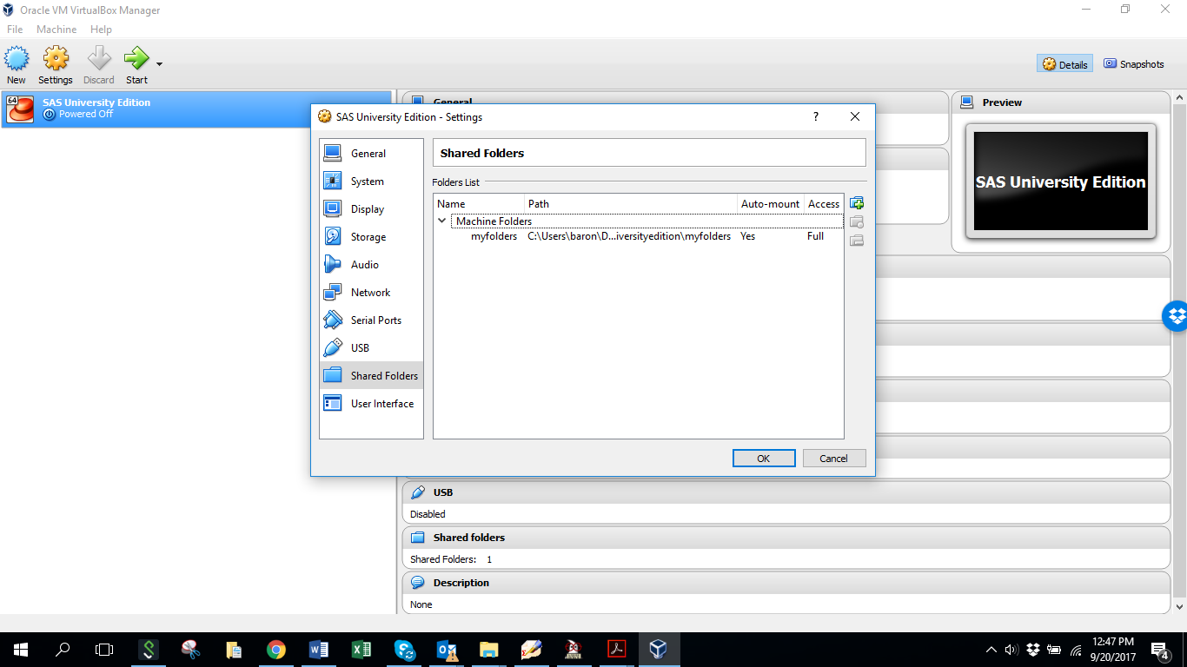
If there is a folder under “Machine Folders”, then this is your shared folder. Locate it on your local computer. You may use it for file transfer between you and SAS.
- Set up a shared folder.
If there is nothing below “Machine Folders”, we’ll have to set up your shared folder.
Within your “My Documents”, create a folder “SASuniversityedition”, open it, and create a subfolder “myfolders”. To create a folder, right-click your mouse and choose New -> Folder. | 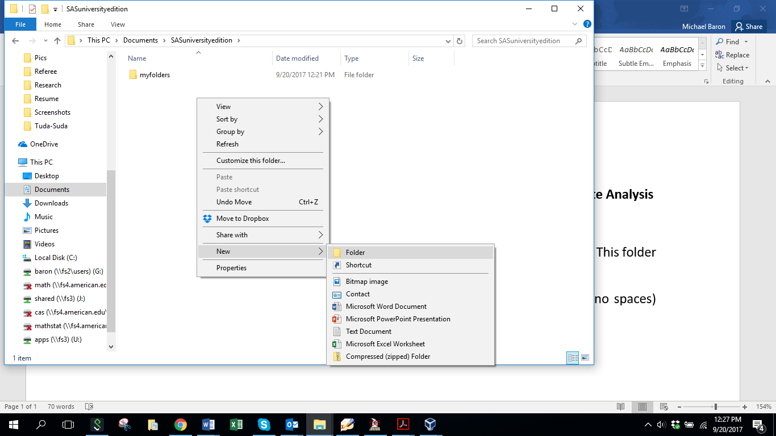

Then, back in Oracle VM VirtualBox Manager’s Settings window, click on a green plus on the right margin, next to the word Access. In the new Add Share window, copy the whole path of your “myfolders” folder.  Check the “Auto-mount” box and uncheck the “Read Only” box.  Click OK, OK, and your shared folder is all set. | 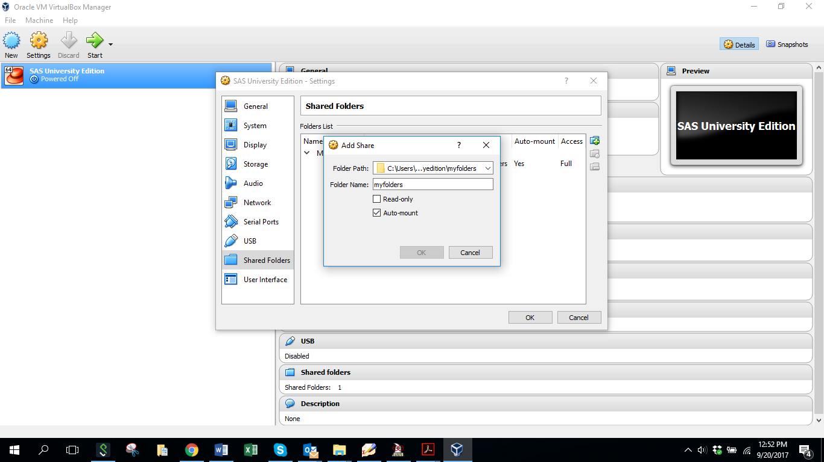

- Using the shared folder.
Now you can save your SAS codes and data files in the shared folder or its subfolders. SAS knows the newly created folder as /folders/myfolders/. For example, you can read data with proc import
PROC IMPORT DATAFILE='/folders/myfolders/pulse.xls'
DBMS=XLS OUT=C; GETNAMES=YES; run;

Or you can click on the folders icon within SAS Studio and click on the data file, in any format acceptable by SAS:
Folders icon text here

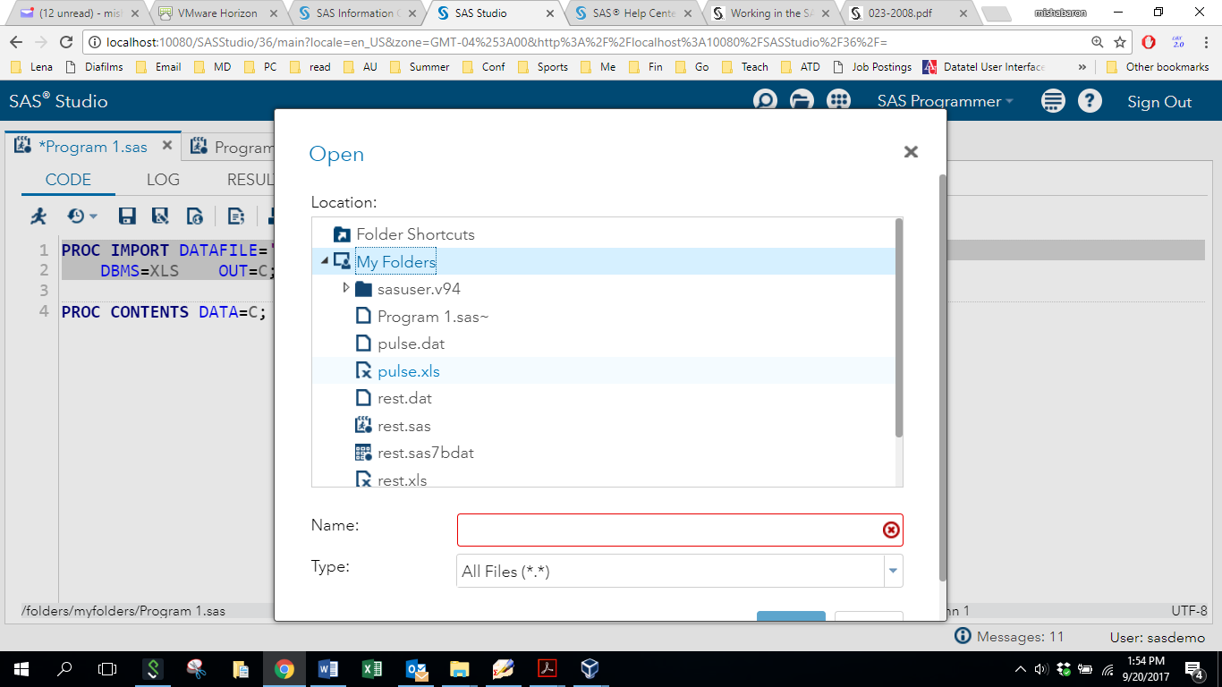

A code for importing that clicked dataset will appear. It is already executable, you can hit F3 to run the code and read the data.

